TEST5

Question No.1: Fuzzy Lookup

Ans: While performing operations, if we are looking for values based on the similarity, it is called fuzzy lookup. With the help of Fuzzy lookup, we can get 3 different results:

1) Exact Match values(if similarity=1) 2) Similar Match values 3) Look like values

We have two different tables: Source table with incorrect spelling and lookup table with correct spelling.

Execution:

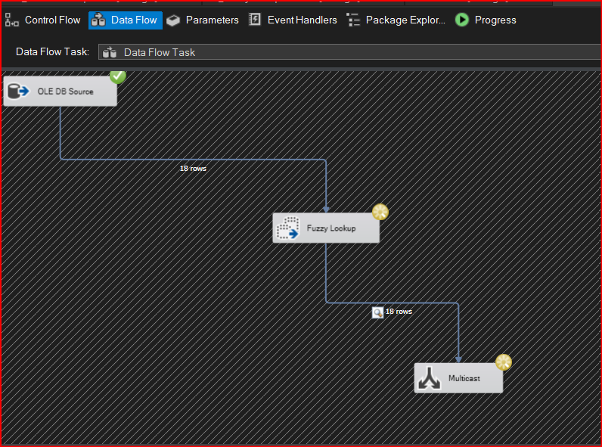

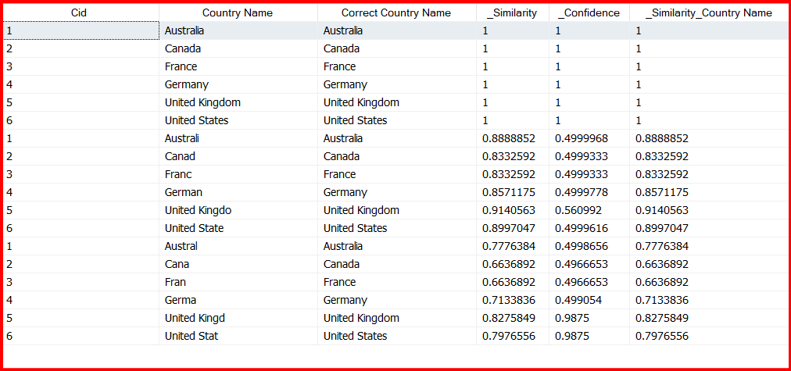

Question No.2 – Normal LookUp

Ans: When we are looking for exact match values, we use normal lookup.

In normal lookup, we have two tables – main table and lookup table.

Normal lookup have two different outputs: Lookup Match Output and Lookup No Match Output.

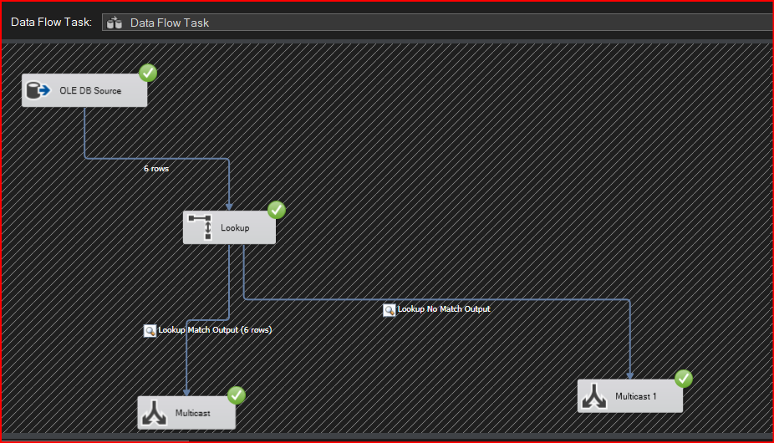

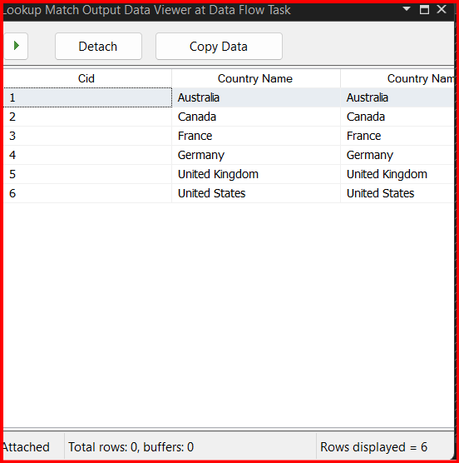

Question No.3 Term LookUp

Ans: Whenever we are looking for a particular word in a sentence, we use TermLookUp.

We use two tables in term lookup – main table in which data is there and term lookup table in which we have a particular word to search for.

We will get the frequency of occurrence of a particular word in a sentence as output.

Output:

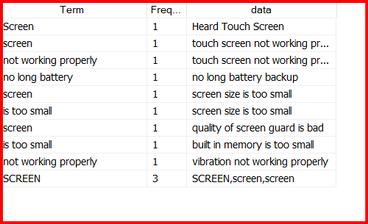

Execution:

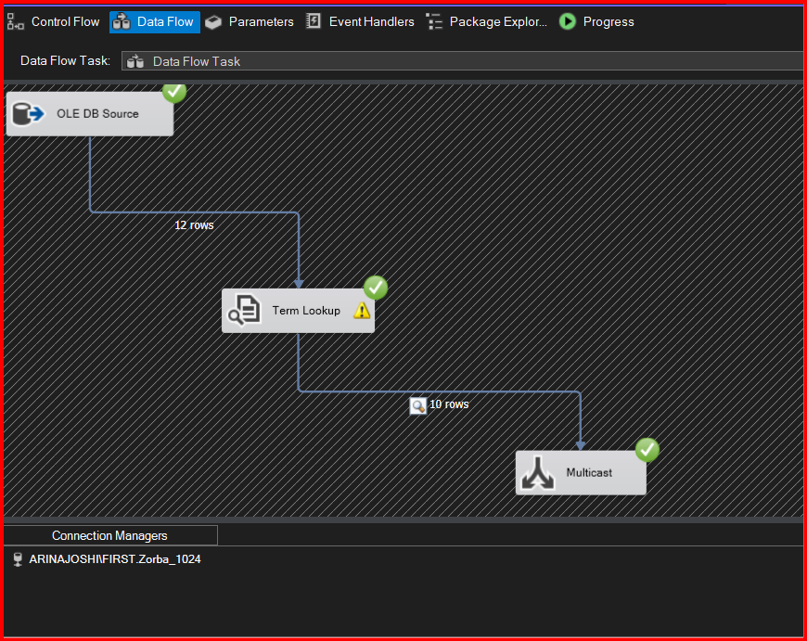

Question No.4 Term Extraction

Ans: When we want to extract term in a sentence, we use Term Extraction.

Terms can be of 3 types: 1) Noun 2) Noun phrase 3) Noun and Noun phrase

Score type can be expressed as 1) Frequency 2) TFIDF.

If we want to exclude particular word, we have the option of Exclusion in Advanced tab for which we need to create exclusion table in SSMS.

SSMS: Two tables : TermReview Table and ExclusionReview table with excluded word

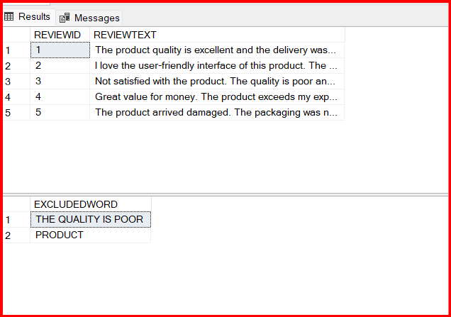

Output:

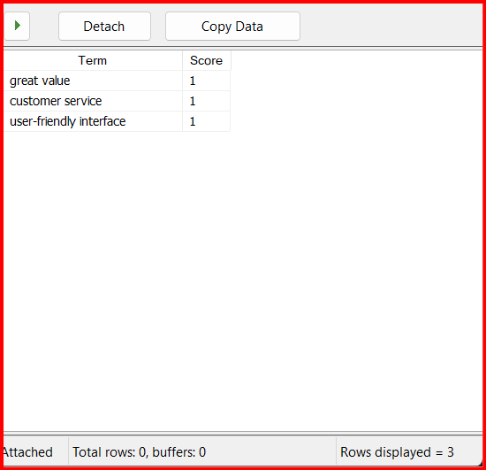

Execution :

